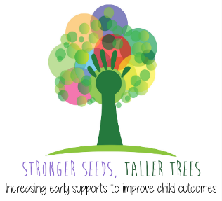
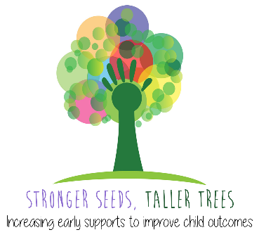
Occupational Therapy – Where and How to Refer

Developmental Concern | Contact Details
- Fine Motor Skills  - Sensory Processing  - Play Skills  - Self-Care Skills | Liverpool | Rainbow Cottage  Phone: 9616 4405  Email: SWSLHD-LiverpoolRainbowCottage@health.nsw.gov.au
 | Fairfield | Fairfield Community Health Centre  Cabramatta Community Health Centre  Phone: 9794 1700  Email: SWSLHD-ChildrensCommunityHealth-OT-Fairfield@health.nsw.gov.au
 | Bankstown | Bankstown Community Health Centre  Phone: 9780 2777 (ask for Child & Family intake)  Email: SWSLHD-ChildrensCommunityHealth-OT-Bankstown@health.nsw.gov.au
 | Macarthur | Ingleburn / Narellan / Rosemeadow / Oran Park Community Health Centres  Phone: 4633 4125  Email: SWSLHD-ChildrensCommunityHealth-OT-Macarthur@health.nsw.gov.au
 | Macarthur  *Complex multidisciplinary needs | The Children’s Allied Health Team  Phone: 4634 3580 & 0408 662 782  Email: SWSLHD-Campbelltown-AlliedHealthAdministration@health.nsw.gov.au

If you have significant concerns regarding a child’s development:

Complete all 3 referrals below:
- Allied Health services
Public – As above
Private – Please provide families with the relevant Medicare plans to access rebates on private services

- Private Developmental Paediatrician

- National Disability Insurance Scheme (NDIS) – Early Childhood Early Intervention (ECEI)
EACH Central Intake Phone: 1300 003 224
Email: info@each.com.au
Website: https://www.each.com.au/service/early-childhood-early-intervention/

If a child is over 7 years old, they can access:
- Private Allied Health services (and relevant Medicare plans)
- The National Disability Insurance Scheme (NDIS) if eligible
https://www.ndis.gov.au/applying-access-ndis/am-i-eligible
- Some public Allied Health services – please enquire with local Community Health Centres

Please contact Meredith Munnoch at Meredith.Munnoch@health.nsw.gov.au to advise of any errors or updates to information in this document.

Stronger Seeds, Taller Trees Project – Occupational Therapy – How and Where to Refer – 6th February 2023

