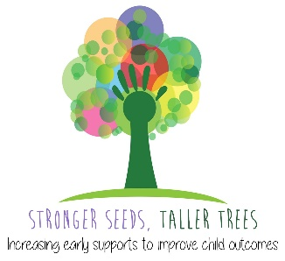

Quick Communication Checklist
Adapted from the Rossetti Infant-Toddler Language Scale and Children’s Communication Checklist

Refer to Speech Pathology if these milestones are not met -
6-9 months:
- Recognises family members names (e.g. mum/dad)
- Responds with a gesture (e.g. arms up) to “come up”
- Early babbling (e.g. bababa, mamama)
- Smiles and laughs during games
- Responds to ‘no’ most of the time
- Waves bye

12 months:
- Makes eye contact (e.g. responds to name by looking at speaker)
- Looks for familiar objects when they are labelled
- Varied babbling (e.g. gamabada, dabagama)
- Emerging use of single words (1-5 single words used)
- Using more gestures (e.g. waving hi & bye, extending arm to show an object, pointing to indicate awareness)
- Imitating more sounds and some familiar words

18 months:
- Saying 6-20 single words (independently i.e. without imitating)
- Able to copy more single words
- Understands 50 words
- Identifies some body parts/clothing items
- Points with their index finger to direct attention

2 years:
- Using more than 50 single words
- Beginning to use two-word combinations (e.g. more water, mummy go, daddy car)
- Follows one- and some two-step instructions (e.g. get the ball and take it outside)
- 50% intelligible (this means, an unfamiliar person understands around half of what they say; there will still be many age-appropriate sound errors)

3 years:
- Uses 4-5 words in a sentence in mostly the correct order
- 75% intelligible (i.e. we understand 75% of what they say as some sound errors are still age-appropriate)
- Asking and responding to simple wh- questions
- Telling short recounts and stories
- Understanding instructions of increasing length and complexity

4 years:
- 100% intelligible (i.e. we understand everything they say, but they may still have difficulty with some sounds)
- Using conjunctions (and, but, because) to make longer sentences (5+ word sentences)
- Responding correctly to most wh- questions
- Emerging awareness that words are made up of sounds e.g. sun starts with ‘sss’ sound

5 years:
- Taking turns in increasingly longer conversations (7+ word sentences)
- Telling simple stories with a beginning, middle and end
- Using correct grammar on most occasions e.g. using the correct tense (e.g. I went/we will go)
- Uses most speech sounds correctly (age appropriate errors: r w and ‘th’ f/v)

