Bankstown-Lidcombe Hospital

Seeking Patient Discharge Summary & access to Information Feedback

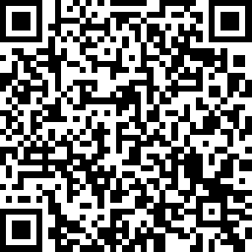

https://www.surveymonkey.com/r/5QQHRBG

This survey will take 3 minutes to complete and your responses are anonymous.

Bankstown-Lidcombe Hospital is seeking feedback on the discharge summaries provided to you when patients leave our service.

Transfer of Care from our services to your care is an important step in the patient journey and we would like to know if we are doing well, and where we can make improvements.

We would also like to know how you access information about the services available at Bankstown-Lidcombe Hospital and how we can make it easier for you and your patients to receive relevant, up to date information.

